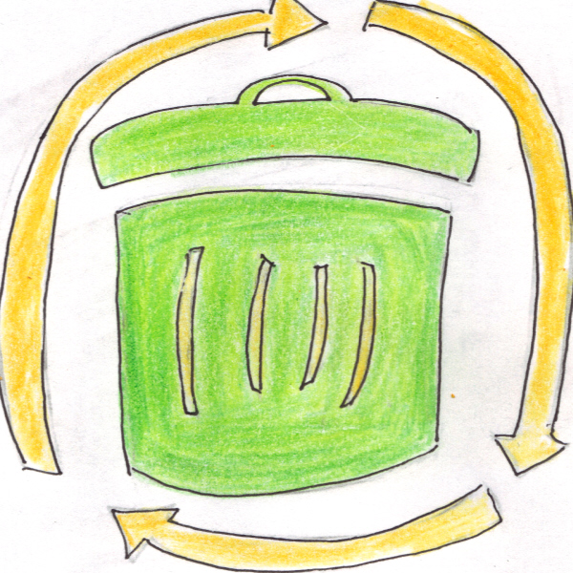
Jonathon Mejias
Our Planet - Our Future
Sage Park Middle School
December 2007
ECO Warriors

THE WINDSOR GREEN SCHEME

This paper outlines my proposal for a community enhancement recycling program which will be piloted at Sage Park Middle School. If the program is a success, I would promote the program in other schools in my community. Schools such as Poquonock, John F Kennedy, and Oliver Ellsworth could benefit from a student run recycling program.

RECYCLED MATERIALS

Sage Park uses many recyclable materials in the lunches they provide. These include Fizzed soft drinks (aluminum), Minute Maid juice (plastic), and milk containers (plastic). The salad containers and other small plastic containers are also recyclable. The most commonly purchased lunch item, the Fizzed can, is recyclable. The Fizzed can, like other aluminum cans, if not recycled, will not decompose. If just thrown away, aluminum cans will still be aluminum cans five hundred years from now.
There is no limit to the amount of times we can recycle an aluminum can. I decided to recycle these materials because they take up about seventeen percent of the average dump.
The Fizzed can is redeemable for 5 cents. The proceeds from recycling could be reinvested to help run the program and will help pay for a portion of the fieldtrip.

WINDSOR WARRIORS FOR A BETTER EARTH

Why is recycling at a school a good idea? Studies have shown that recycling is good for the earth, and offers many benefits for the student body. Programs like this have been proven to improve student’s behavior, self respect, build leadership, and character.

This type of program has been implemented in other schools and has been very successful. Examples of some of the successful programs include* “PETE, Worms and Kids” (Parkway North High School), “Trash to Treasure” (Pattonville school district), “Earth Savers” (Parkwood Elementary School), and “We Think We Can, We Think We Can” (Wydown Elementary School.)

The program could be used to teach students responsibility as well as introducing students to the concept of local community service. Just one recycled can will save enough energy to run a TV for three hours. Recycling programs are beneficial to the environment and the world. It is our responsibility to do our part in this battle for our planets survival. This program also offers Sage Park the opportunity to continue developing good relations with the community and a chance at winning the “Environmental Excellence” award. This award would be an honor for any school to attain, and would likely be publicized in local news papers. This would bring the students and school administration a great sense of school spirit and pride.

MOTIVATION & COMPETITION

At Sage Park, the students are separated into teams. There are three teams in each grade. I would use the teams as recycling groups. We would create a competitive environment in which we would challenge each of the teams to see which team can recycle the most items. Working in a team atmosphere will make its members feel important and equally useful. Working in a competitive team setting has been proven to be a good motivator in similar settings.

Each team (recycle-group) will be supplied with one bin for the recyclables. The bins will be labeled ‘Team 1’, ‘Team 2’, ‘Team 3’ … to match the team they are used by. When a bin is filled it will be brought to a specified location and emptied. For each full bin, the responsible team will be awarded a set number of points.

On Wednesdays and Fridays I would stay after school to separate the redeemable material from the unredeemable material. The Windsor Sanitation Company would pick up the unredeemable recyclable material. The redeemable material would be brought to the West Hartford Redemption Center by my mother and me. All the money would then be brought back to the school and put into a student fund. The fund would eventually be used to pay a portion of the cost of a field trip. The team that recycles the most material will be awarded a field trip to North West Park.

Also there would be competitions to help market the program. Some of these would include best poster designs, best program slogan, and also since each team has a mascot the person that best explains the positive outcomes for the animal by recycling will also win a prize. The prizes will be ten-dollars each for the mascot essays and slogan competitions. Twenty-dollars will be awarded to the student that designs the best poster. This will total $120 in cash prizes. This will give the students more say in the program and feelings of importance. Cash prizes also always arouse excitement in middle school students.

GETTING STARTED

To get started and maintain interest in the program a weekly report would take place on the daily school announcements. The announcements could give information like the total amount of bins filled with recyclables, which team is in first place, and also fun facts about recycling. An example of a fun would be a aluminum thrown away today would still exist 500 years from now, or a aluminum can could be recycled continuously and never

The recycling bins themselves would serve as fun reminders. They will be decorated with things such as the team’s animal mascot, and the words, “Save Our Planet” right under the animal’s picture. This will remind students that they are making a difference in the world. Hopefully these positive habits will carry on into the student’s adult lives. The bins will also be marked with phrases such as, “Almost There!”, “You really could do better”, “Fill me up”, and “You did it!” We will also decorate the school with posters supporting the recycling program.

To kick of the program off, we would hold assemblies for both the teachers and students to explain our goals, the program rules, and how each person can make a difference. The first assembly would be for the teachers and other school staff. It is important that the school faculty support the program if it is to succeed. The second assembly will be held for the students. We will invite keynote speakers that are active in the community to speak on behalf of the program and our environment.

SUPPLIES NEEDED

To make the plan work I will need the basic supplies listed below:
- Nine recycling receptacles (supplied by Windsor Sanitation Company)
- Large clear trash bags, and plastic gloves (supplied by school)
- Materials to decorate bins and create posters (paid for by my family)

The recycling receptacles will be used as the recycle bin by students to drop off their recyclables at lunch. Plastics and aluminum will be put into these containers. One bin would be given to each team. The trash bags will be placed in the recycling bin to prolong their use and also make collection, sorting, and storage more efficient and sanitary. The gloves will be used for handling the recyclable materials during collection and sorting because mistakes may occur and food matter may be placed in the recycling bins. The spray paint will be used to decorate the recycling bin along with posters.

FIELD TRIP

Besides the basic supplies I propose we reward the team that recycles the most. The team that recycles the most will receive a fieldtrip to North West Park. The students could be transported by rented buses. The students will enjoy a day of fun activities related to the environment. The students will be supplied with a lunch.

Information about the field trip and permission slips would be sent home with the winning team members explaining the program and field trip. Parents will be invited to chaperone or send food such as chips, sodas. Besides outside support, the field trip will also be funded in part by money redeemed from the recycled items, and also in part by any grants that may be received as funding for the program.
To get all of the supplies I estimate it will cost approximately $90.
To give the awards I estimate I will need $__________
In all, I estimate that it will cost $_________ to run the program.

After the field trip an assembly will be held honoring all of the students at Sage Park that were involved in the program and they will get a certificate and a wrist band that says, “ECO WARRIORS’’.

With last year’s temperature at an all time high a program like this is desperately needed. This program will raise awareness of the simple steps that can be taken to help stop global warming and also make our world and community a cleaner and better place to live.

FACTS ABOUT PLASTIC POLLUTION

About four-fifths of marine trash comes from land, swept by wind or washed by rain off highways and city streets, down streams and rivers, and out to sea. Nearly 90% of floating marine litter is plastic.

Not all litter is deliberate. 47% of wind borne litter escaping from landfills is plastic. Much of this is plastic bags. In the marine environment plastic bag litter is lethal, killing at least 100,000 birds, whales, seals and turtles every year. After an animal is killed by plastic bags, its body decomposes and the plastic is released back into the environment where it can kill again.
Resources gathered from Environmental Education in Missouri,
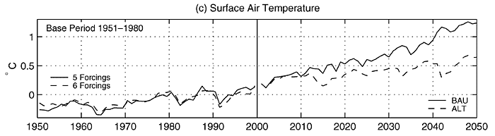
http://www.colostate.edu, Missouri Department of Conservation, and http://www.kilowattours.org (Kilowatt Ours is an advocacy documentary film produced by Jeff Barrie and Southern Energy Conservation Initiative.)

